**Practical session 6**

*For the practical parts of this lab (implementing programs, running them) please save the Python programs that you create and take screenshots of the execution (evaluation) of your programs. Commit (upload) all source code you create to your code repository.*

**Tasks:**

1. What is the error in this statement?

if scoreA = scoreB :

print("Tie")

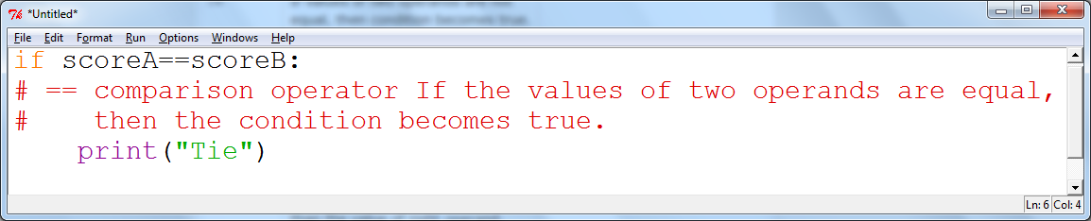

2. Supply a condition in this if statement to test if the user entered a “Y”:

userInput = input("Enter Y to quit.")

if . .user . // supply statement

print("Goodbye") // if the user entered “Y”

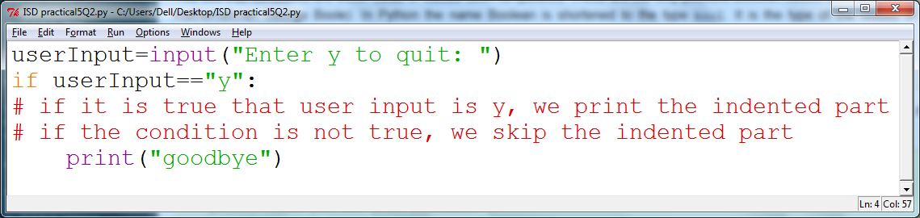

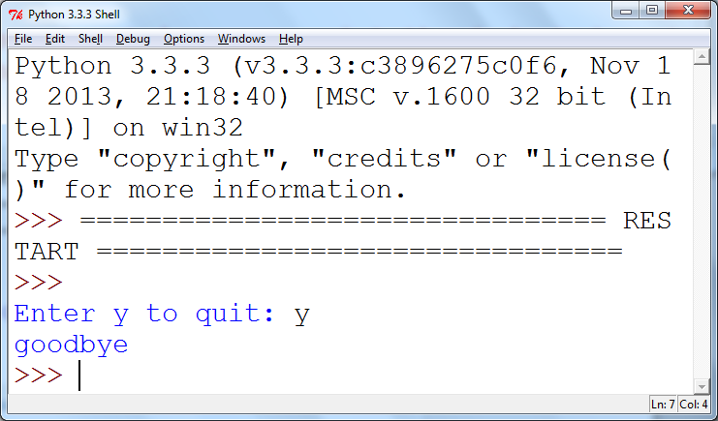

3. Find the errors in the following if statements, correct where necessary.

a) if x > 0 then :

print(x)

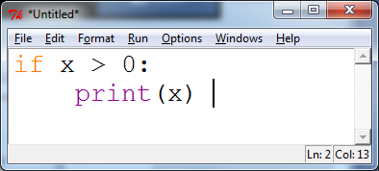

b) if 1 + x > x ** sqrt(2) :

y = y + x

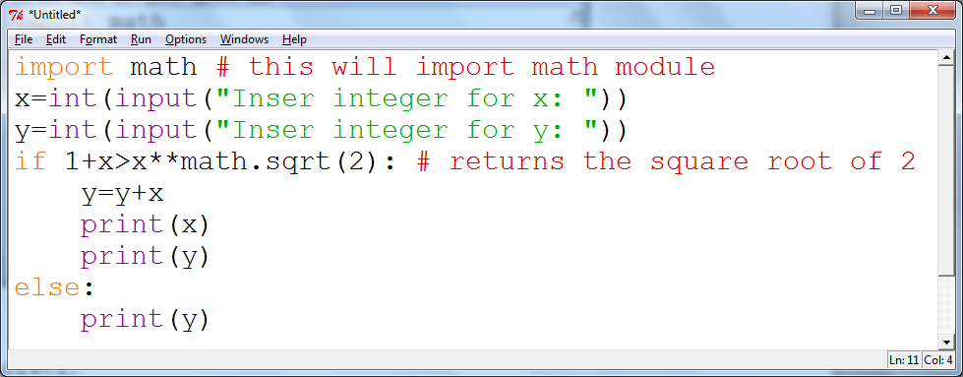

c) if x = 1 :

y += 1

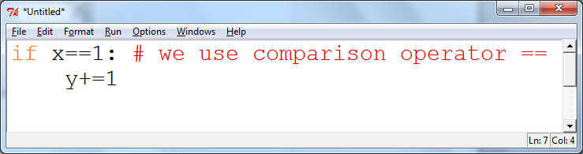

d) letterGrade = "F"

if grade >= 90 :

letterGrade = "A"

if grade >= 80 :

letterGrade = "B"

if grade >= 70 :

letterGrade = "C"

if grade >= 60 :

letterGrade = "D"

else

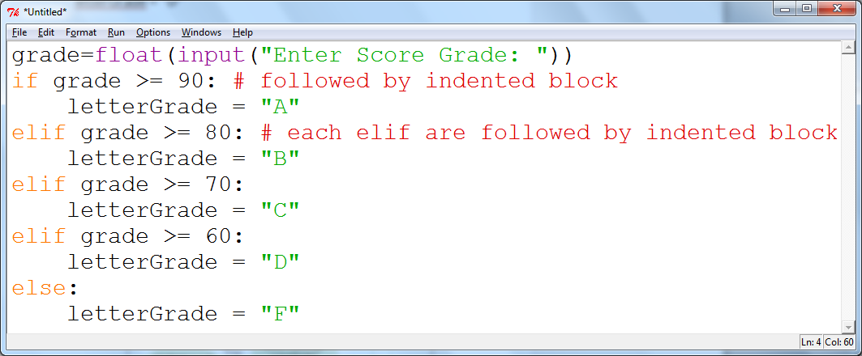

4. Using the flow chart below, construct the *if, elif, else* control structure necessary to implement the flow chart.

Complete your program to describe the earthquake by asking the user to enter a magnitude on the Richter scale and print out the effect that magnitude would have had (e.g. “Many buildings destroyed”).

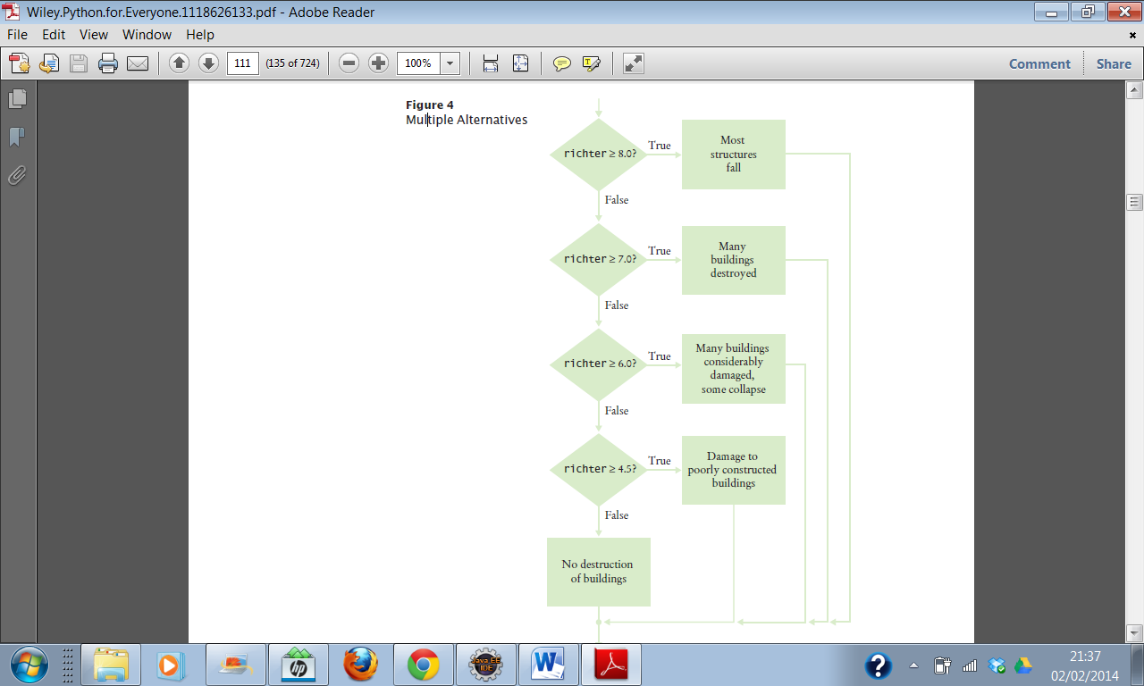

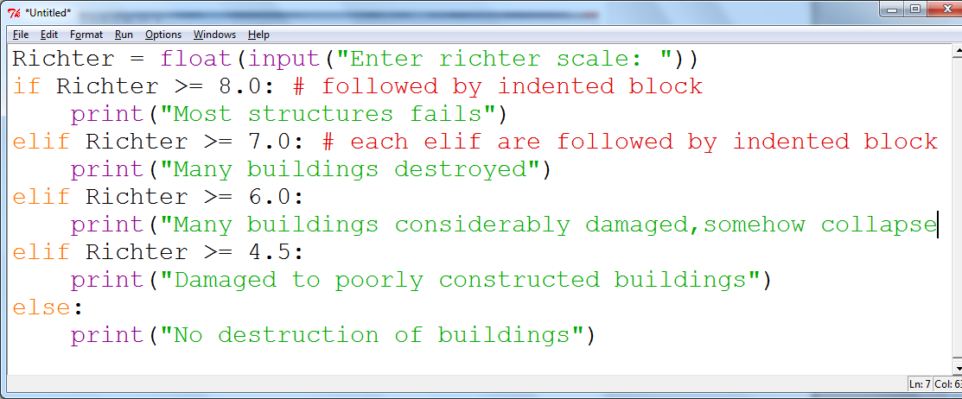

5. Write a program that sets a password as “changeme” and asks the user to enter the password and keeps asking until the correct password is entered and then says “Accepted”.

The program should count how many attempts the user has taken and tell them after they have been accepted.

*Extra Challenge:*

If the user takes more than 5 attempts the program should say, “Access denied, please press enter to exit and contact security to reset your password”

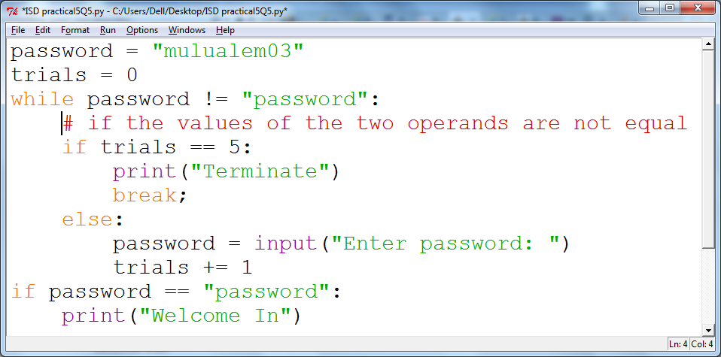

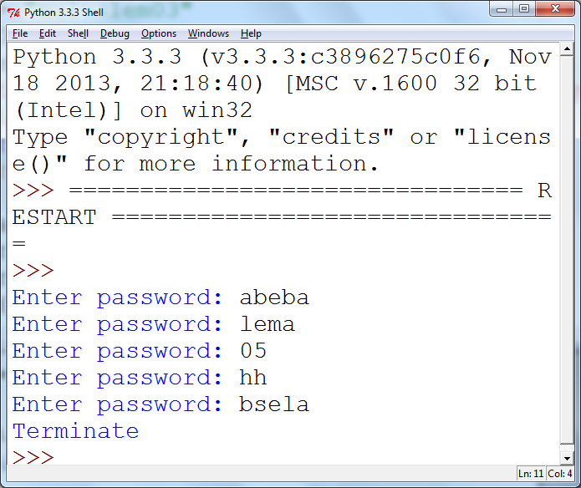

7. What do the following nested loops display? Hand trace.

for i in range(3) :

for j in range(1, 4) :

print(i + j, end="")

print()

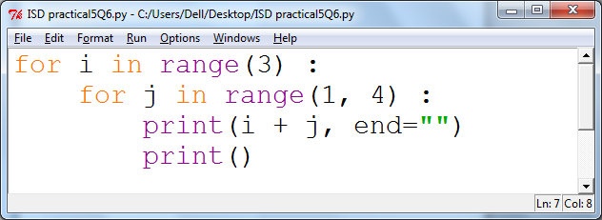

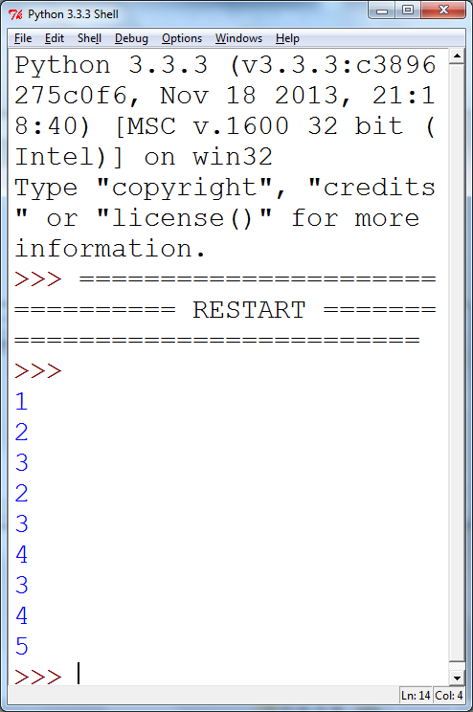

8. Write a program that will generate a table to print powers of the first 5 numbers. Your output should be similar to the sample given below.

